SOLENOIDS

# Prepared By:

M Waleed Javed – Fa17-BCS-104

M Rehan – Fa17-BCS-103

Saad Ali – Fa17-BCS-112

Hamza Abbasi – Fa17-BCS-082

# Materials Used:

* Copper wire
* Metal rod
* Magnet
* Battery
* Wires
* Led

# Background knowledge:

Before we move on to ‘Working’ we should 1st know what is a solenoid,

* Solenoid:

“Solenoid is the generic term for a coil of wire used as an electromagnet.”

It also refers to any device that converts ‘electrical energy’ to ‘mechanical energy’ using a solenoid.

The device creates a magnetic field from electric current and uses the magnetic field to create linear motion.

* Right Hand Rule is used to determine direction of magnetic field.

# Making of a solenoid:

Solenoid can be formed in various ways, the most common type of solenoids are formed by wrapping the copper wire over the metal rod in circular motion like a spiral over a rod.

# WORKING:

Solenoids operate on Faradays principle of Electro-magnetism, solenoid is a coil of wire in a corkscrew shape wrapped around a piston, often made of iron. As in all electromagnets, a magnetic field is created when an electric current passes through the wire. Electromagnets have an advantage over permanent magnets in that they can be switched on and off by the application or removal of the electric current, which is what makes them useful as switches and valves, and allows them to be entirely automated.

Like all magnets, the magnetic field of an activated solenoid has positive and negative poles that will attract or repel material sensitive to magnets.

In a solenoid, the electromagnetic field causes the piston to either move backward or forward, which is how motion is created by a solenoid coil.

In case of Electromagnetic induction of current in a loop ,the magnet is moved in a to and fro motion within the rod which changes the Magnetic flux in the loop and we know that, changing flux produces current, which then powers the LED and the lied start to glow.

# COMMON –APPLICATIONS:

Solenoids are incredibly versatile and extremely useful. They're found in everything from

* Automated factory equipment to paintball guns and even doorbells.
* In a chime doorbell, the audible chime is produced when a metal piston strikes a tone bar. The force that moves the piston is the magnetic field of a solenoid that receives electric current when the doorbell is pushed.

Common applications of solenoids are to

* Power a switch
* Starter in an automobile, or a valve, such as in a sprinkler system.
* Transformer Cores

# DIagram of solenoid:

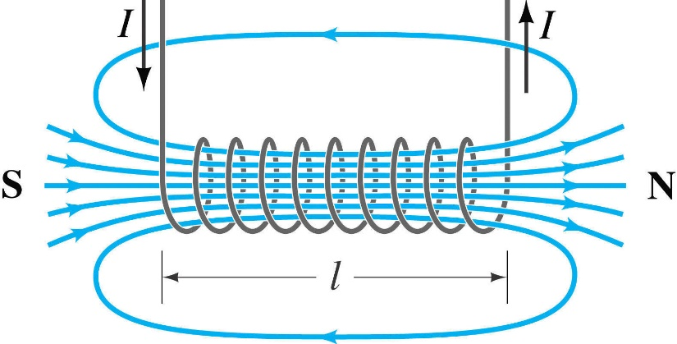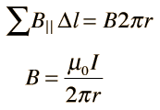Following formula can be used to find the magnetic field of solenoid,